**Character Name:** Azrael Orphanus,

**Class:** Hex-blade Warlock

**Backstory:**

Apallo, a Shadar-Kai, experienced the murder of his daughter Oracle. Stricken by grief and guilt, he isolated himself and spiraled into darkness. At his lowest point, contemplating suicide, he was offered a pact by the Raven Queen. The pact granted him the power to seek vengeance against Oracle’s killer. Apallo’s journey is fueled by the pursuit of justice, fealty to the Raven Queen*, and the vulnerability tied to Oracle’s death.

*Unknown to Azrael, the Raven Queen is behind Oracle’s death.

**Feats:**

* ***Elven Accuracy****:*

**Personality Traits:**

Azrael is brooding and inquisitive.

**Ideals:**

Vengeance for Oracle above all else

**Bond:**

* **Fealty to the Raven Queen**

**Flaws:**

Sensitive and emotionally irrational regarding anything concerning his daughter.

**Appearance:**

Age: 128 – Eyes: Black – Height: 6’0 – Weight: 185

**Motivations:**

Avenging the Death of Oracle

Carrying out The Raven Queen’s Will

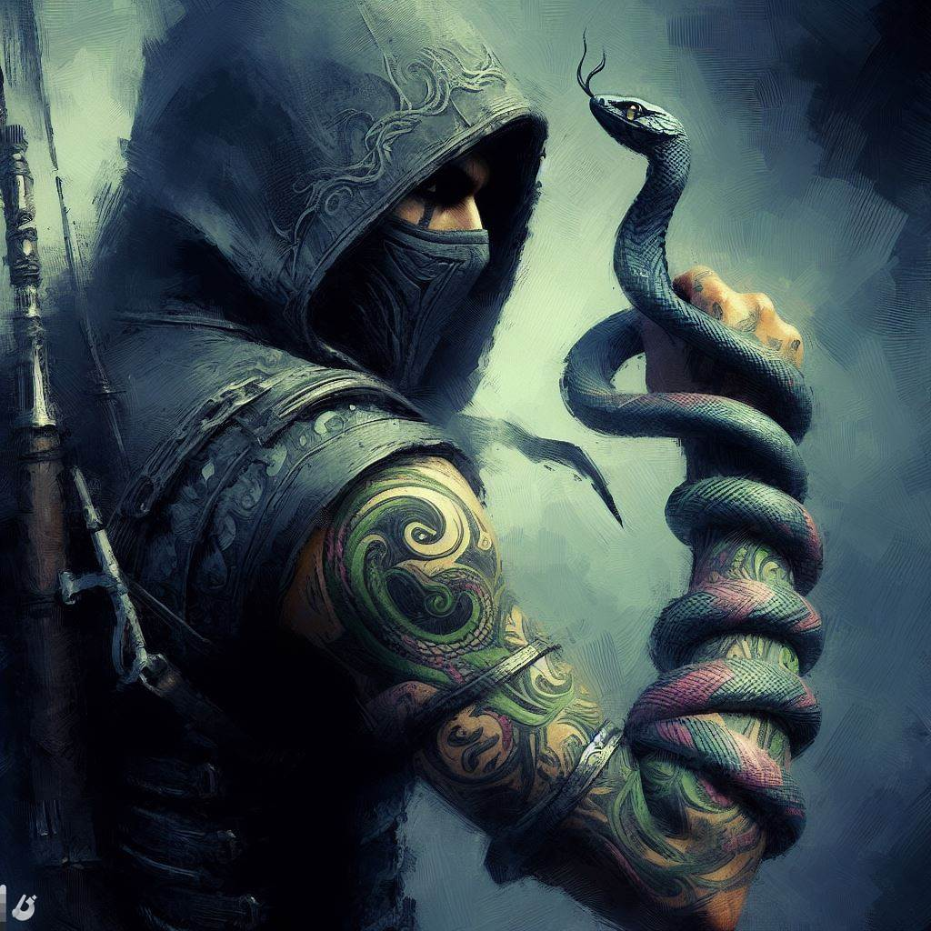

***Oracle’s Murderer***

Nyxus, the Shadow Assassin

**Race: ** Shadar-Kai Elf

**Age: ** Late-middle aged

**Appearance: **

- Wears dark clothing and a concealing mask.

- Lithe, agile, and deadly.

- Carries a shadow-absorbing blade.

- Distinguishing Features: Twisting serpent tattoo on left hand, black snake familiar

**Motivation: ** (Unknown to Azrael)

- Tasked by the Raven Queen with Oracle's murder.

- Released from the pact upon completing the assignment.

**Known Traits: **

- Exceptional stealth and infiltration skills.

- Leaves no discernible trace.

- Expert in hand-to-hand combat and assassination techniques.

- Snake familiar aids in killing

**Backstory: ** (Unknown to Azrael)

- Former Warlock of the Raven Queen.

- Fulfilled the Raven Queen's demand for Oracle's death.

- Released from the pact upon completion.